DCS Final Project

**Team Name:** Miau

**Team members:** Socaci Cristian Marius

Varga Andrei

Dioane Radu-Alexandru

# Component diagram for the controllers and the two intersections

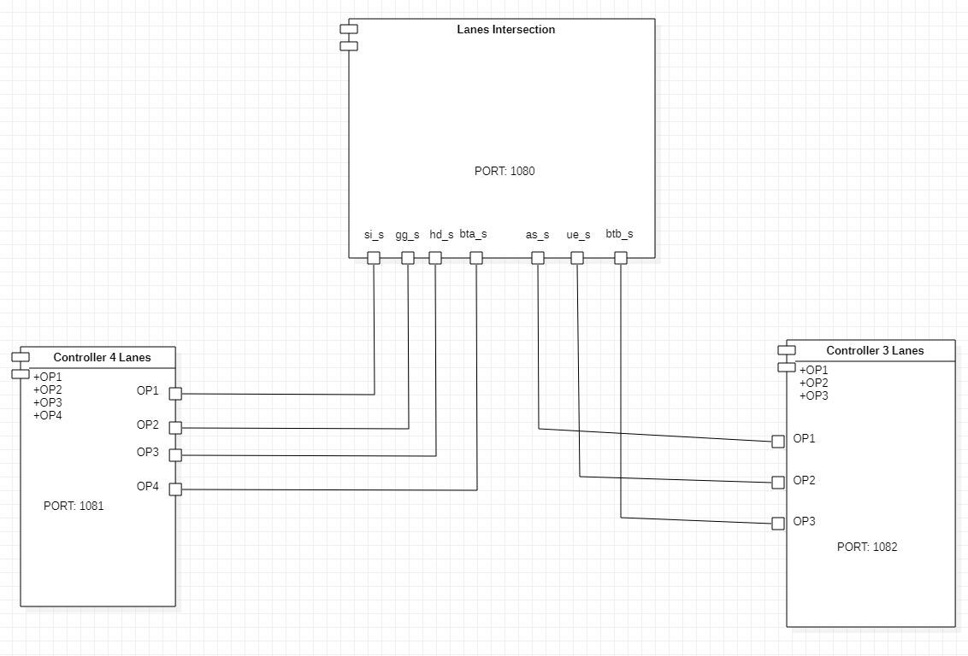

1. **OETPN model for the lane (the one with the input channel)**

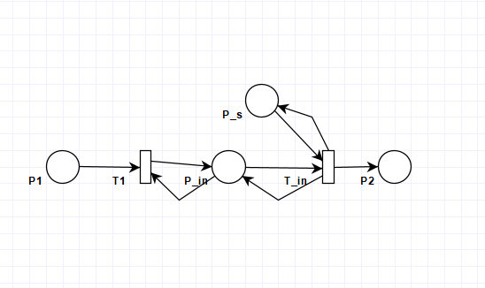

## Transitions guards and mappings:

T1 guard: if (P1 != null) and (P_in CanAddCars)

Mappings: P_in AddElement from P1

T_in guard: if (P_s == “green”) and (P_in HaveCar)

Mapping1: P_in PopElementWithoutTarget to P2

Mapping2: P_s Move to P_s

# The two intersections from Google Maps and the OETPN model

## Screenshot of the two intersections from Google Maps:

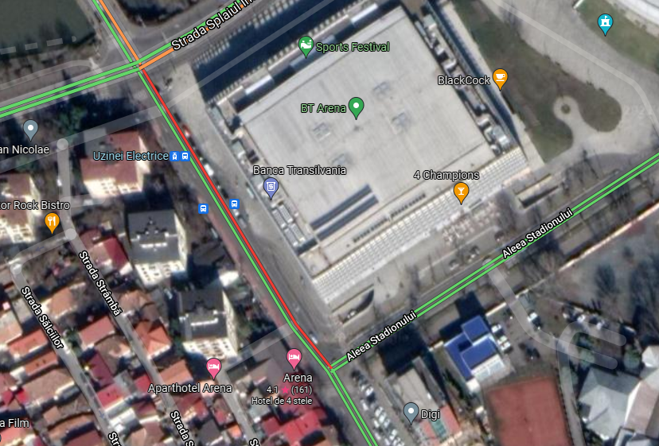

**Screenshots from Google Maps for the 4-way intersection:**

## Lane 1 (right one) and 2 (middle one):

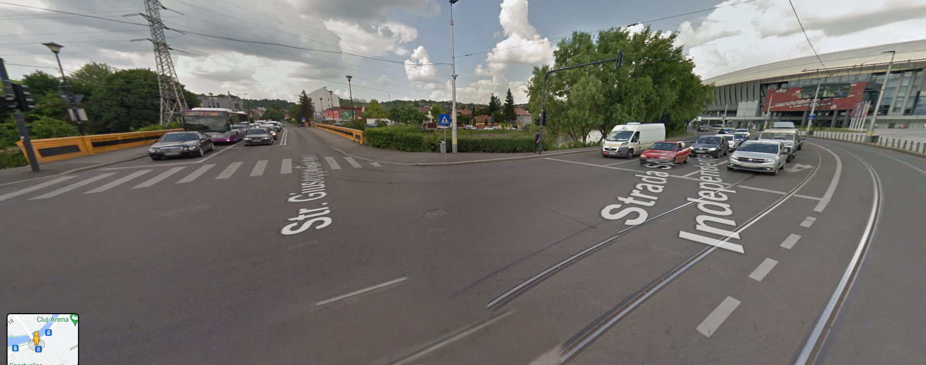

**Lane 3 ( middle one) and Lane 4 ( left one):**

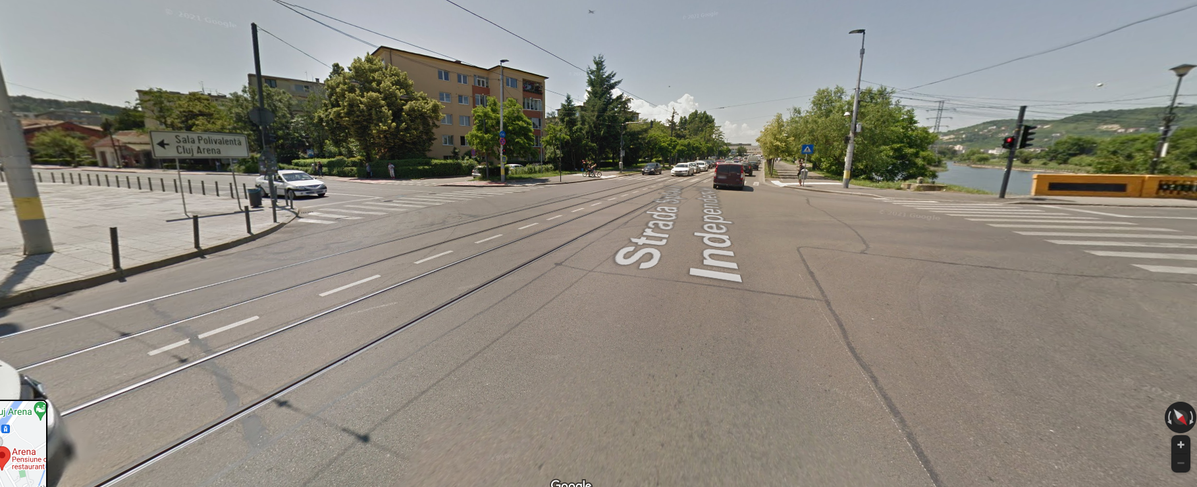

# OETPN model of the two intersections:

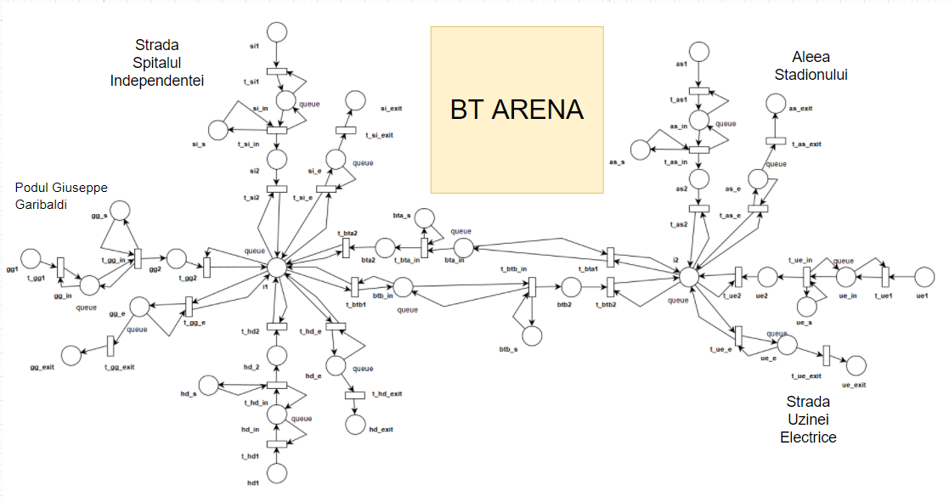

## Transitions guards and mappings:

## T_si1 guard : if (si1 NotNull) and (si_in CanAddCars)

## Mappings : si_in AddElement From si1

Similar guards and mappings for T_gg1,T_hd1,T_as1,T_ue1

T_bta1 guard: if (i2 HaveCarForMe) and (bta_in CanAddCars)

Mappings: i2 PopElementWithTargetToQueue to bta_in

Similar guards and mappings for T_btb1

## T_si_in guard : if (si_s == “green”) and (si_in HaveCar)

## Mappings : si_in PopELementWIthoutTarget To si2 , si_s Move to si_s

## Similar guards and mappings for T_gg_in,T_hd_in,T_bta_in,T_btb_in,T_as_in,T_ue_in

## T_si2 guard : if(si2 NotNull) and (i1 CanAddCars)

## Mappings : i1 AddElement From si2

## Similar guards and mappings : T_gg2, T_hd2, T_bta2, T_btb2, T_as2, T_ue2

## T_si_e guard: if (i1 HaveCarForMe) and (si_e CanAddCars)

## Mappings: i1 PopElementWithTargetToQueue si_e

## Similar guards and mappings for T_gg_e, T_hd_e, T_as_e, T_ue_e

## T_si_exit guard: if (si_e HaveCar)

## Mappings: si PopElementWithoutTarget to si_exit

## Similar guards and mappings for T_gg_exit, T_hd_exit, T_as_exit, T_ue_exit

# Experiment

During the experiment 3 cars have been sent through the 2 intersection that we had designed. They started in the place si1 and their first target was the t_btb1 transition which is the one of the output lanes of our first intersection and in the same time the input lane to our second intersection (the connector transition if it can be put that way). After arriving into our second intersection, the car will search for the desired exit which in our case is the transition t_as_e and will end in the as_exit place which means, it successfully covered our imposed path.